Player Performance Prediction

4 Theory and Method

* Data Processing

We extracted game log table of each player from a sport website and calculate their monthly average of time on ice in Excel by using pivot table.

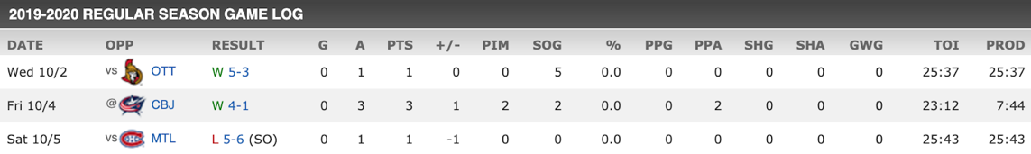

The table shows that there are null columns which indicates that some records are missing. To solve this problem, we filled out those null columns by using average TOI of last four months. Besides, we have to remove the records of season 2012-2013 with just four months due to political reason.

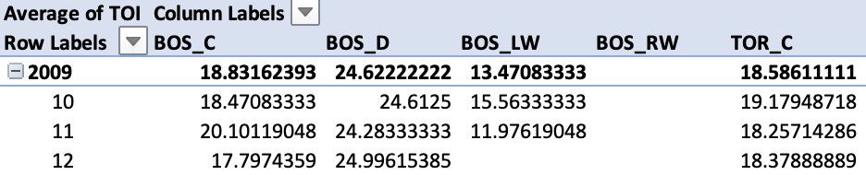

* PACF plot Analysis

PACF plots help us tell the relationship between the performance in neighboring months. Since it is obvious that the significance lags of most of the graphs are 1, except for the one for player Andreas who is a new player without much data to show trends, so we could see a strong relationship between the performance in neighboring months.

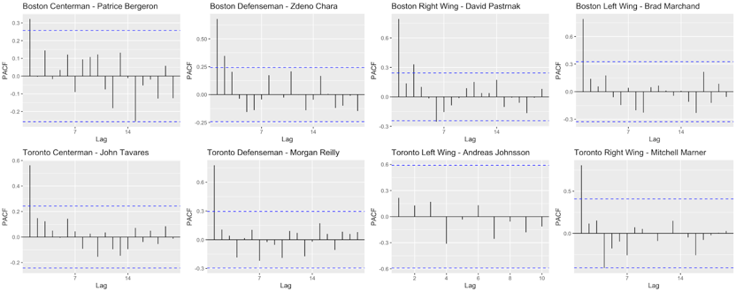

* TOI Auto Plot

TOI: it measures total amount of time a player is on the ice during the playing of the game; it is an indicator of how a coach views the player and their contribution with more time going to players considered to be producers either through point production or point prevention.

We output the auto plot of time on ice of four example players in each team. And the plots show the different trend and the range of TOI.

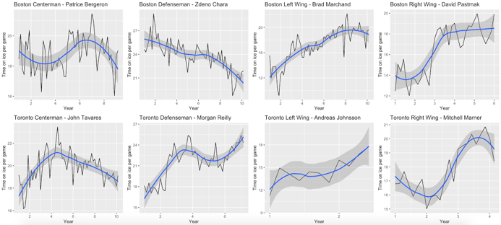

* Seasonality Analysis

Seasonality is the presence of variations that occur at specific regular intervals less than a year, such as weekly, monthly. Polar maps of the performance of 8 players in Boston Bruins and Toronto Maples.

What we could see from the polar maps:

* which month has better performance
* seasonal performance stationarity

The difference between line to the middle of the polar map is the level of TOI. Some players like Brad Marchand shows a stable history performance in almost every month from the polar map. While some players like the captains in both teams, they reached a high TOI record in a certain month, such as season beginning in Oct. or at the end of season in April.

